Dear Parents, Colleagues and Friends,
This academic year has been an indisputably brilliant success for the school and all of its students. It has been a real honour and privilege to manage the school along with my teaching colleagues. There are three simple words that sum up the year for me:
Pride, Joy and Sadness
Pride
Boys have attended a wider range of work experience placements than ever before and have experienced catering, horticulture, agriculture, retail, charity work, building maintenance and car mechanics. In every instance, the students have developed new skills, impressed those they have been working with and received praise from all they encountered.
Examination entry and success has hit dizzier heights than ever before. Many boys achieved significant certification in a variety of ASDAN units, Functional Skills exams and Level one qualifications in subjects such as British Values. In addition, GCSE examinations in Maths, English, Physics, Chemistry, Biology, History and English Literature and PE were sat and we are very optimistic that the August results will give us much to celebrate.
Sporting achievements continued to amass as students trained and competed in new sports such as Tennis, Swimming and Gymnastics.
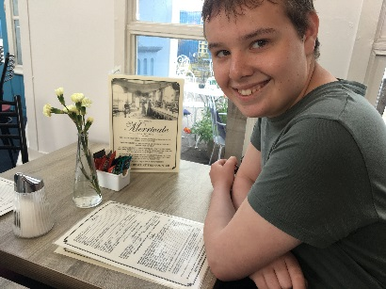
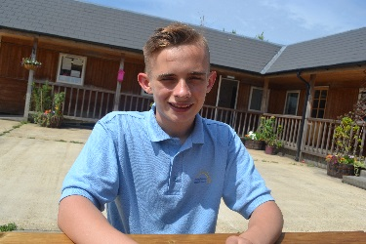
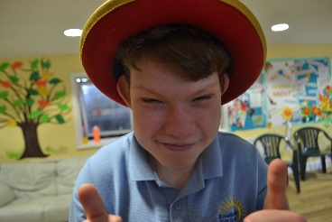
On June 20th we will hold our annual Sports and Awards Afternoon. This is an occasion for the boys to have fun, competing in team challenges, before the awards for progress and excellence in all the topics we have covered this year are announced. There are awards for Attendance, Citizenship and Tennis, as well as the usual academic subjects.

Joy
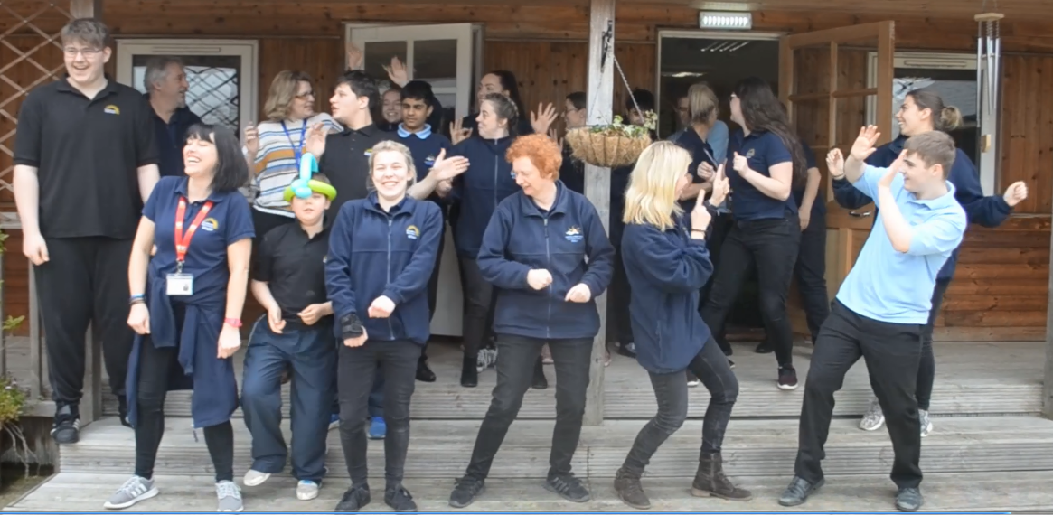
The above represent just some of the things that have made me so Proud I could burst and the way the boys and our staff have participated, worked together and smiled their way through challenges and adversity has ensured the school has been a truly Joyful place. We (staff and students) laugh together every day and we cry frequently, tears of joy, in response to the milestones achieved and obstacles overcome. The video we made for our Easter Extravaganza captures ‘us’ rather well! Please ask if you would like a copy.
Sadness
Finally, as some of you may know, I resigned from my post in March and I feel heartfelt sadness to be leaving this amazing school at the end of the summer term but I am moving on to take up the Headship of large Special School that needs some help to realise it’s potential. The past four years have been simply wonderful. Having the opportunity to work with the incredible Broadlands Hall School team to improve the school and raise standards for our wonderful young men has been extremely satisfying. Thanks to everyone’s skill and effort, I leave the school in excellent order with a culture of honest and continuous reflection and self-improvement - so I am confident it can thrive into the future.
The whole school went to see the musical ‘Wicked’ a few weeks ago. The song, Changed, sums up how I feel about the entire Broadlands Hall School community:
‘Who can say if I've been changed for the better?
But because I knew you
I have been changed for good.’
Goodbye and thank you most sincerely for all for your support, input and the opportunity to know these amazing young people.
Hazel J Simmons - Headteacher

